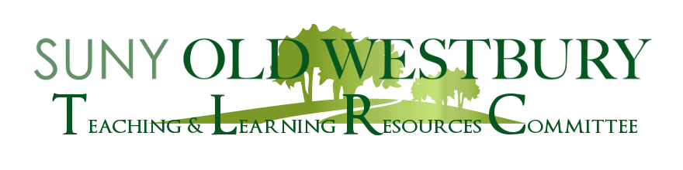

**SAVE THE DATE**

**Advising Workshop**

**with Yumi Nicholson**

**Senior Academic Advisor &**

**Administrative Coordinator of General Education**

Co-Sponsored by:

**The Teaching and Learning Resources Committee (TLRC)**

and

**The Student Life Committee (SLC)**

**Wednesday, February 15th**

**2:40 pm- 3:40 pm**

**Via Zoom**

**Meeting ID: 818 8754 0537**

**Passcode: 26582**

Please join us for a discussion about advising, where the focus will be on filling the expectation gaps between students and faculty. The available advising tools, including Connect OW, Navigate, and Degree Audit, will be reviewed. Ask questions and get answers as we get ready to advise our students and continue to support their success at Old Westbury.